# Map of Edinburgh and South East of Scotland City Region

## Cultural Industries - Creative Informatics

### Aims

This document aims to outline the geographical boundaries of the Edinburgh and South East of Scotland City Region Deal (ESESCR) as outlined in the map below. By defining clearly where the boundaries are, data collection can be defined for the purposes of academic research and reporting.

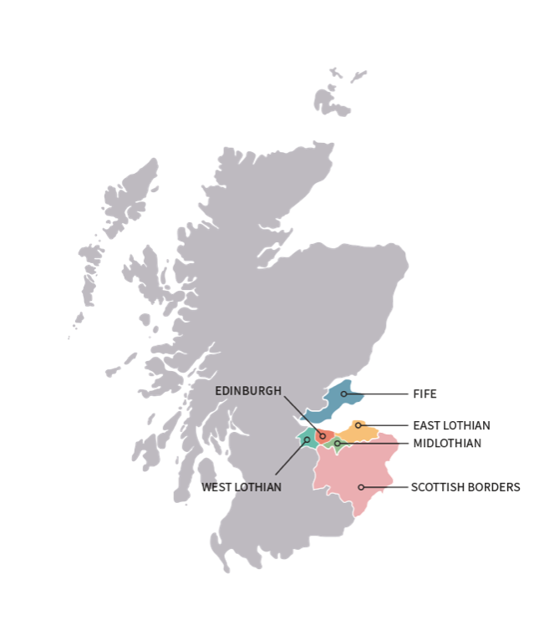

Figure : Map of the Edinburgh and South East Scotland City Region Deal (<http://www.acceleratinggrowth.org.uk>)

### Objectives

The ESESCR comprises of six local authorities:

1. Edinburgh City Council (ECC)
2. East Lothian Council (ELC)
3. Mid Lothian Council (MLC)
4. West Lothian Council (WLC)
5. Scottish Borders Council (SBC)
6. Fife Council (FC)

The objective of this piece of research was to establish which postcodes fall under the ESESCR jurisdiction. It was conducted with the specific purpose to be able to ‘map’ the creative industries in the ESESCR. Postcode data are used to geolocate data on a geographical map. As administrative boundaries do not align to postcode boundaries. There is no formal agreement from partners of the ESESCR on a precise definition of the geographical boundaries of the City Deal other than the geographical map depicted (Fig. 1). This document sets out which postcodes it will consider under the ESESCR.

The Objective of the paper is thus to have an agreed geographical remit, expressed in postcodes, that will define the ESESCR and can be used for research and reporting purposes.

## Mapping the Edinburgh and South East of Scotland City Region Deal

The mapping of the ESESCR is based on the UK Parliamentary Constituencies, which were derived from the interactive UK Parliamentary Constituencies Map (Fig. 2) available from Map Room.net (<https://maproom.net/demo/election-map/0.html>). Full, static, maps can also be downloaded from the Boundaries commission Scotland: <https://www.bcomm-scotland.independent.gov.uk/5th-review-constituency-maps> Do UK Parliamentary Constituencies align with Council boundaries?!



Figure : Map of the Parliamentary Constituencies which make up the Edinburgh and South of Scotland City Deal (source: <https://maproom.net/demo/election-map/0.html>)

|  |  |  |  |
| --- | --- | --- | --- |
|  | **Council Authority** | **Parliamentary Constituencies** | **Postcodes** |
| 1 | Edinburgh City Council (ECC) | Edinburgh East  Edinburgh North and Leith  Edinburgh South  Edinburgh South West  Edinburgh West |  |
| 2 | East Lothian Council (ELC) |  |  |
| 3 | Mid Lothian Council (MLC) |  |  |
| 4 | West Lothian Council (WLC) |  |  |
| 5 | Scottish Borders Council (SBC) |  |  |
| 6 | Fife Council (FC) |  |  |

The data used to determine the postcodes areas are derived from these three sources:

Doogal: <https://www.doogal.co.uk/AdministrativeAreas.php> . This site contains Ordnance Survey data (OS), Royal Mail data and National Statistics Data (ONS). All are subject to copyright.

Postcodes via <https://www.townscountiespostcodes.co.uk> and <https://www.postcodes-uk.com>

### Edinburgh City Council



Figure : Map of EH postcode area (https://www.townscountiespostcodes.co.uk and https://www.postcodes-uk.com )

<https://www.doogal.co.uk/UKPostcodes.php?Search=EH>

Edinburgh City Council comprises of five Parliamentary Constituencies, listed below. The postcodes in Edinburgh City Council follow predominantly in the EH postcodes. However, there are some anomalies:

|  |  |  |
| --- | --- | --- |
| **Edinburgh City** | **First 3digits Postcodes** | **Source** |
| Edinburgh East | EH1 (1AD) – (1UQ) | <https://www.doogal.co.uk/ElectoralConstituencies.php?constituency=S14000022> |
| <https://www.doogal.co.uk/ElectoralConstituencies.php?constituency=S14000022> | | |
| Edinburgh North and Leith | EH1 (1AA) – (3QW) | <https://www.doogal.co.uk/ElectoralConstituencies.php?constituency=S14000023> |
| <https://www.doogal.co.uk/ElectoralConstituencies.php?constituency=S14000023> | | |
| Edinburgh South | EH10 (4AA) – (4TA) | <https://www.doogal.co.uk/ElectoralConstituencies.php?constituency=S14000024> |
| <https://www.doogal.co.uk/ElectoralConstituencies.php?constituency=S14000024> | | |
| Edinburgh South West | EH1 (1PF) – (2RN)  EH10 (1AQ) –(7JA)  EH11 (1AA) –(1AY) | <https://www.doogal.co.uk/ElectoralConstituencies.php?constituency=S14000025> |
| <https://www.doogal.co.uk/ElectoralConstituencies.php?constituency=S14000025> | | |
| Edinburgh West | EH1 (1RZ) – (9AR)  EH11 (1DJ) –(3PE) | https://www.doogal.co.uk/ElectoralConstituencies.php?constituency=S14000026 |
| <https://www.doogal.co.uk/ElectoralConstituencies.php?constituency=S14000026> | | |

1. Edinburgh City: EH1-EH17 + EH28 to EH30 +
2. Midlothian: (EH10) + EH18 to EH20 + EH22 to EH26 + EH37 + EH46
3. East Lothian: EH21 to EH22 + EH31 to EH36 + EH39 to EH42 + (TD13)
4. West Lothian: EH27 + EH30 + EH47 to EH49 + EH51 to EH55

There is no EH50 postcode. EH95 and EH99 are excluded. EH99 is the postcode for the Scottish Parliament and EH95 appears to be a dedicated postcode for Scottish Gas.

### East Lothian Council (ELC)

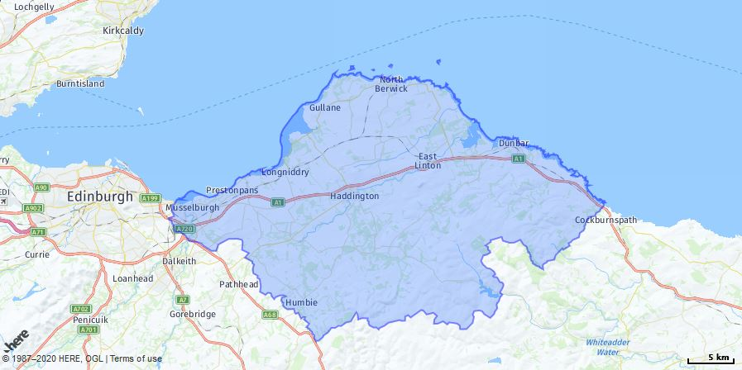

East Lothian Council comprises of 6 Electoral Wards, listed below. The postcodes in East Lothian follow predominantly in the EH21, EH22,EH33 -39, EH40-42 postcodes. However, there are some anomalies:

### <https://www.eastlothian.gov.uk/downloads/download/12766/ward_profiles>

|  |  |  |
| --- | --- | --- |
| **East Lothian** | **First 3digits Postcodes** | **Source** |
| Dunbar and East Linton | EH40(3AA)-(3YW)  EH41 (3SB)- (4QF),  EH42 (1AA)- (1ZW),  TD13 (5WA)- (9AB), | https://www.doogal.co.uk/AdministrativeAreas.php?district=S12000010&ward=S13002913 |
|  | | |
| Haddington and Lammermuir | EH33 (2AL)- (2NQ),  EH34 (5AA)- (5YD),  EH35 (5AB)-(5YE),  EH36 (5PA)-(5PX),  EH37 (5UJ)-(5UL),  EH39 (5AZ)-(5LQ),  EH41 (3AA)-(9ZZ),  TD11 (3SP)- (3SW) | https://www.doogal.co.uk/AdministrativeAreas.php?district=S12000010&ward=S13002912 |
|  | | |
| Musselburgh | EH21 (6AA)- (9AZ) | https://www.doogal.co.uk/AdministrativeAreas.php?district=S12000010&ward=S13002908 |
|  | | |
| North Berwick Coastal | EH31 (2AA)-(2ZY),  EH32 (0BF)-(0WU),  EH39 (4AA)-(9AY),  EH40 (3DE)-(3DZ),  EH42 (1XA)-(1XT), | https://www.doogal.co.uk/AdministrativeAreas.php?district=S12000010&ward=S13002911 |
|  | | |
| Preston, Seton and Gosford | EH21 (8JL)-(8JS),  EH32 (0AA)-(9YP),  EH33 (1NA)-(1NB),  EH41 3SW | https://www.doogal.co.uk/AdministrativeAreas.php?district=S12000010&ward=S13002909 |
|  | | |
| Tranent, Wallyford and Macmerry | EH21 (8AA)-(8YX),  EH22 (2NL)-(2NW),  EH33 (1AA)-(9AH),  EH34 (5BG)-(5YL),  EH35 5WW,  EH41 3SX | https://www.doogal.co.uk/AdministrativeAreas.php?district=S12000010&ward=S13002910 |
|  | | |

### Mid Lothian Council (MLC)

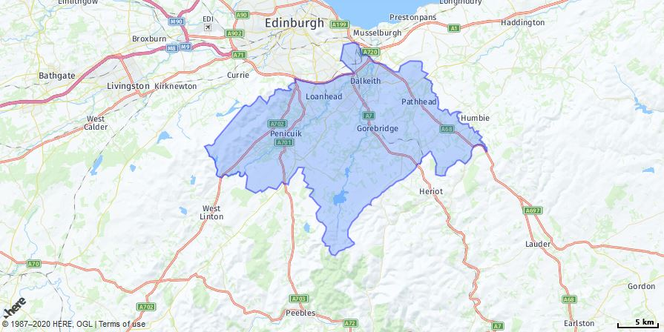

https://www.doogal.co.uk/AdministrativeAreas.php?district=S12000019

Mid Lothian Council comprises of 6 Electoral Wards, listed below. The postcodes in Mid Lothian follow predominantly in the EH16-26 postcodes. However, there are some anomalies:

|  |  |  |
| --- | --- | --- |
| **Mid Lothian** | **First 3digits Postcodes** | **Source** |
| Bonnyrigg | EH18 (1AA)-(1YH),  EH19 (2AA)-(9AP),  EH20 (0AA)-(9ZA),  EH22 (3LZ)-(3ND),  EH24 (9WA)-(9YB) | https://www.doogal.co.uk/AdministrativeAreas.php?district=S12000019&ward=S13003019 |
|  | | |
| Dalkeith | EH16 (4SL)-(4SN),  EH21 (8RY)-(8RZ),  EH22 (1AA)-(9ZZ),  EH23 (4WA)-(4YN),  EH37 (5YA)-(5YJ)  EH38 5ZB | https://www.doogal.co.uk/AdministrativeAreas.php?district=S12000019&ward=S13003020 |
|  | | |
| Midlothian East | EH17 8SA,  EH18(1AH)-(1HW),  EH19 2BF,  EH22 (1SU)-(5ZX),  EH23 (4NN)-(4PA),  EH37 (5AH)-(5XS) | https://www.doogal.co.uk/AdministrativeAreas.php?district=S12000019&ward=S13003022 |
|  | | |
| Midlothian South | EH19 (3HU)-(3JQ),  EH22 (3LY)-(4YP),  EH23 (4AA)-(4YG),  EH24 (9AX)-(9EU),  EH26 (8PG)-(9LL),  EH37 5XU | https://www.doogal.co.uk/AdministrativeAreas.php?district=S12000019&ward=S13003023 |
|  | | |
| Midlothian West | EH10(7DP)-(7GZ),  EH17 8SB,  EH18 (1EA)-(1HY),  EH20 (9AA)-(9YE),  EH24 (9AA)-(9EY),  EH25 (9AA)-(9ZF),  EH26 (0BA)-(8PF) | https://www.doogal.co.uk/AdministrativeAreas.php?district=S12000019&ward=S13003021 |
|  | | |
| Penicuik | EH25 (9WA)-(9ZJ),  EH26 (0AA)-(9YZ),  EH46 7BE | https://www.doogal.co.uk/AdministrativeAreas.php?district=S12000019&ward=S13003018 |
|  | | |

### West Lothian Council (WLC)

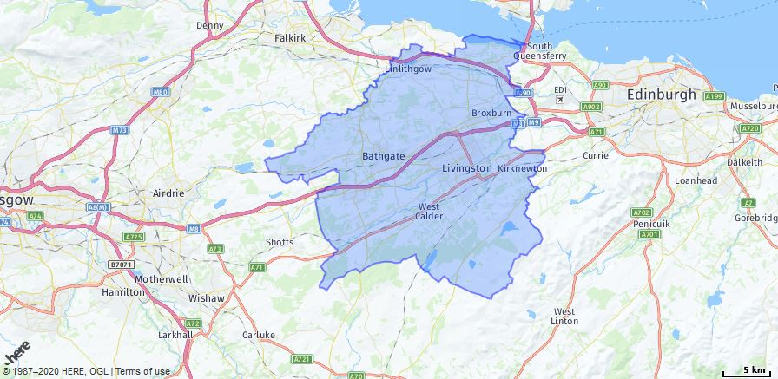

West Lothian Council comprises of 9 Electoral Wards, listed below. The postcodes in West Lothian follow predominantly in the EH27-30, EH47-55 and ML7 postcodes. However, there are some anomalies:

|  |  |  |
| --- | --- | --- |
| **Mid Lothian** | **First 3digits Postcodes** | **Source** |
| Armadale and Blackridge | EH48 (2FN)-(4QN),  EH49 6PN,  FK1 (2JU)-(2NL) | https://www.doogal.co.uk/AdministrativeAreas.php?district=S12000040&ward=S13002828 |
|  | | |
| Bathgate | EH47(0WA)-(9YE),  EH48 (1AA)-(4YZ),  EH52 6LS,  EH54 (8QX)-(8TB) | https://www.doogal.co.uk/AdministrativeAreas.php?district=S12000040&ward=S13002827 |
|  | | |
| Broxburn, Uphall and Winchburgh | EH28(8YB)-(8YP),  EH29 9EF,  EH52 (5AA)-(6ZE),  EH54 5QF | https://www.doogal.co.uk/AdministrativeAreas.php?district=S12000040&ward=S13002821 |
|  | | |
| East Livingston and East Calder | EH14 7JQ,  EH27 (8AA)-(8YG),  EH52 (5PD)-(5SW),  EH53 (0AA)-(0YZ),  EH54 (5AA)-(6LN),  EH55 (8LP)-(8RX) | https://www.doogal.co.uk/AdministrativeAreas.php?district=S12000040&ward=S13002824 |
|  | | |
| Fauldhouse and the Breich Valley | ML11 8TS,  EH47 (8AA)-(9LZ),  EH55 (8AA)-(8YG) | https://www.doogal.co.uk/AdministrativeAreas.php?district=S12000040&ward=S13002825 |
|  | | |
| Linlithgow | EH2,  EH30 (9SH)-(9SU),  EH48 (4NP)-(4PD),  EH49 (6AA)-(9BH),  EH52 (6GB)-(6QZ) | https://www.doogal.co.uk/AdministrativeAreas.php?district=S12000040&ward=S13002820 |
|  | | |
| Livingston North | EH54 (6AB)-(9FE) | https://www.doogal.co.uk/AdministrativeAreas.php?district=S12000040&ward=S13002822 |
|  | | |
| Livingston South | EH27 (8WA)-(8YQ),  EH53 (0RL)-(0YY),  EH54 (0AA)-(9ZH),  EH55 (8FA)-(8YT) | https://www.doogal.co.uk/AdministrativeAreas.php?district=S12000040&ward=S13002823 |
|  | | |
| Whitburn and Blackburn | EH28 (8NF)-(9AD),  EH47 (0AA)-(9ZX),  EH48 (1EY)-(9DJ),  EH52 (5WH)-(9AL),  EH54 (7AB)-(8TE),  EH55 (8PL)-(8PW),  ML7 (5QP)-(5TB) | https://www.doogal.co.uk/AdministrativeAreas.php?district=S12000040&ward=S13002826 |
|  | | |

### Scottish Borders Council (SBC)

### 

The Scottish Borders falls under the Berwickshire, Roxburgh and Selkirk UK Parliamentary Constituency, and is one large geographical constituency (See Fig. 2). The Scottish Borders Council comprises of 11 Electoral Wards, listed below. The postcodes in the Scottish Borders Council Area follow predominantly in the TD postcodes. However, there are some anomalies:

Scottish Borders Postcode Area:

Scottish Borders: TD1 to TD15 + ML12 + (EH26) + EH38 + EH43 to EH46. These should already be included in the larger Edinburgh region and viceversa (see point i-iv)

|  |  |  |
| --- | --- | --- |
| **Wards Scottish Borders Council Area** | **First 3digits Postcodes** | **Source** |
| East Berwickshire | TD11  TD13  TD14  TD15 | <https://www.doogal.co.uk/AdministrativeAreas.php?district=S12000026&ward=S13002767> |
|  | | |
| Galashiels and District | TD1  EH37 (5XT)  EH38 (5XB) – (5ZA) | <https://www.doogal.co.uk/AdministrativeAreas.php?district=S12000026&ward=S13002763> |
|  | | |
| Hawick and Denholm | TD8 (6PH)  TD8 (6PS)  TD9 (7AA) – (9TQ) | <https://www.doogal.co.uk/AdministrativeAreas.php?district=S12000026&ward=S13002770> |
|  | | |
| Hawick and Hermitage | DG14 0RU  TD9 (0AA) – (9YQ) | <https://www.doogal.co.uk/AdministrativeAreas.php?district=S12000026&ward=S13002771> |
|  | | |
| Jedburgh and District | TD5 (7PE) to (8WA)  TD6 (0AA) to (9EU)  TD8 (6AA) to (9AB)  TD9 (8SH)-(8TE) | <https://www.doogal.co.uk/AdministrativeAreas.php?district=S12000026&ward=S13002769> |
|  | | |
| Kelso and District | TD5 (7AA) to (9AQ)  TD8 (6NH) – (6NJ) | <https://www.doogal.co.uk/AdministrativeAreas.php?district=S12000026&ward=S13002768> |
|  | | |
| Leaderdale and Melrose | TD1 (2NP) to (3TE)  TD2 (6AA) to (6YZ)  TD3 (6LD) to (6LG)  TD4 (6AA) to (6YZ)  TD5 (7SB) – (7SE)  TD6 (0YA) – (9YS) | <https://www.doogal.co.uk/AdministrativeAreas.php?district=S12000026&ward=S13002765> |
|  | | |
| Mid Berwickshire | TD10 (6AB) to (6ZA)  TD11 (3AA) to (9AF)  TD12 (4AA) to (9AF)  TD14 (5LR)  TD15 (1SU) to (1XW)  TD2 (6SE)(6SH)(6SQ)  TD3 (6ER) – (6YD)  TD4 (4BB)  TD5 (7PT) – (7TW) | <https://www.doogal.co.uk/AdministrativeAreas.php?district=S12000026&ward=S13002766> |
|  | | |
| Selkirkshire | TD1 (3NZ) – (3PQ)  TD6 (0AF) – (9JW)  TD7 (4AA) – (9AF)  TD9 (7NG)(7NQ)(8SF) | <https://www.doogal.co.uk/AdministrativeAreas.php?district=S12000026&ward=S13002764> |
|  | | |
| Tweeddale East | EH43 (6AA) to (6YA)  EH44 (6HA) to (6YD)  EH45 (8NE) to (9YH)  TD1 (1TJ) to (3PW) | <https://www.doogal.co.uk/AdministrativeAreas.php?district=S12000026&ward=S13002762> |
|  | | |
| Tweeddale West | EH11 (3XW)  EH26 (8NX) – (9NQ)  EH32 (0TT)  EH44 (6WB) to (6YH)  EH45 (6AA) to (9YS)  EH46 (7AA) to (7YQ)  ML12 (6FA) to (6QS) | <https://www.doogal.co.uk/AdministrativeAreas.php?district=S12000026&ward=S13002761> |
|  | | |

### Fife Council (FC)

Only South Fife is included in the Edinburgh & South East Scotland City Region Deal. We were advised by Fife Council to use the UK Parliamentary Constituency for that North East Fife falls into Tay Cities Deal and that the constituencies of Glenrothes; Kirkcaldy & Cowdenbeath and Dunfermline & West Fife) falls under the ESESCR remit.

As such we propose the following postcodes:

Fife Postcode Area:

* + 1. Fife: KY1 to KY16 + DD6 + FK10
       1. Kirkcaldy: KY1 and KY2
       2. Cowdenbeath: KY4
       3. Dunfermline: KY11 and KY12 and FK10?
       4. Glenrothes: KY6 and KY7

|  |  |  |
| --- | --- | --- |
| **South Fife divided by parliamentary constituency** | **First 3digits Postcodes** | **Source** |
| **Kirkcaldy and Cowdenbeath** | KY1 1AA | https://www.doogal.co.uk/ElectoralConstituencies.php?constituency=S14000041 |
|  | | |
| **Dunfermline and West Fife** | KY11 (1AA)-(1FE),  FK10 (3Qd)-(4SF),  FK14 7NR | https://www.doogal.co.uk/ElectoralConstituencies.php?constituency=S14000017 |
|  | | |
| **Glenrothes** | KY1 (2YF)-(4ZB),  KY2(5YG)-(6AR) | https://www.doogal.co.uk/ElectoralConstituencies.php?constituency=S14000036 |
|  | | |

‘

|  |  |  |
| --- | --- | --- |
| **South Fife divided using administrative areas** | **First 3digits Postcodes** | **Source** |
| **Kirkcaldy** |  |  |
| Kirkcaldy Central | KY1 (1AA)-(4YG),  KY2 (5AA)-(9DU) | https://www.doogal.co.uk/AdministrativeAreas.php?district=S12000047&ward=S13002955 |
|  | | |
| Kirkcaldy East | KY1 (1AG)-(5AG),  KY2 (5AG)-(6HQ) | https://www.doogal.co.uk/AdministrativeAreas.php?district=S12000047&ward=S13002956 |
|  | | |
| Kirkcaldy North | KY2 (5AF)-(6ZW) | https://www.doogal.co.uk/AdministrativeAreas.php?district=S12000047&ward=S13002954 |
|  | | |
| **Cowdenbeath** | KY11 (5EG)-(7RG),  KY4 (0AA)-(9ZF),  KY12 0SW | https://www.doogal.co.uk/AdministrativeAreas.php?district=S12000047&ward=S13003128 |
|  | | |
| **Dunfermline and West Fife** |  |  |
| Dunfermline Central | KY11 (1HR)-(9ZU),  KY12 (0DF)-(9ZB),  KY99 (0PP)-(9PP) | https://www.doogal.co.uk/AdministrativeAreas.php?district=S12000047&ward=S13002947 |
|  | | |
| Dunfermline North | KY12 (0AA)-(9YQ) | https://www.doogal.co.uk/AdministrativeAreas.php?district=S12000047&ward=S13002946 |
|  | | |
| Dunfermline South | KY11 (3AU)-(9ZY) | https://www.doogal.co.uk/AdministrativeAreas.php?district=S12000047&ward=S13002948 |
|  | | |
| West Fife and Coastal Villages | FK10 (3QD)-(4SD),  KY12 (0RX)-(9ZQ),  KY4 (0JJ)-(0JW) | https://www.doogal.co.uk/AdministrativeAreas.php?district=S12000047&ward=S13003131 |
|  | | |
| **Glenrothes** |  |  |
| Glenrothes Central and Thornton | KY1 (3NN)-(4YB),  KY6 (1JY)-(3YJ),  KY7 (4AA)-(9ZZ) | https://www.doogal.co.uk/AdministrativeAreas.php?district=S12000047&ward=S13002959 |
|  | | |
| Glenrothes North, Leslie and Markinch | KY6 (3AA)-(3ZB),  KY7 (4QH)-(6ZW) | https://www.doogal.co.uk/AdministrativeAreas.php?district=S12000047&ward=S13002958 |
|  | | |
| Glenrothes West and Kinglassie | KY5 (0HN)-(0ZD),  KY6 (1AA)-(3JE),  KY7 (4NQ)-(6NQ) | https://www.doogal.co.uk/AdministrativeAreas.php?district=S12000047&ward=S13003129 |
|  | | |

IP

30 June 2020